Rough estimate of execution times runs fastest with

1) 1.5k pullup from SDA to 3.3V

2) 8mA mode, and

3) no glitch mode

4) without scope attached

// with 1.5k without

// SSD1306_OutClear 24.8ms 26.2ms, clears entire display

// SSD1306_OutBuffer 24.7ms 26.1ms, sends 1024 bytes, 128 by 64 pixels

// SSD1306_DrawBMP 91us 91us, (10 by 16 size), doesn't output,

// SSD1306_OutChar 196us 207us, does output to OLED

// SSD1306_OutUDec 983us 1038us, outputs 5 characters to OLED

// SSD1306_ClearBuffer 153us 153us, empties buffer, not OLED output

1.5k with glitch (377.5 kHz)

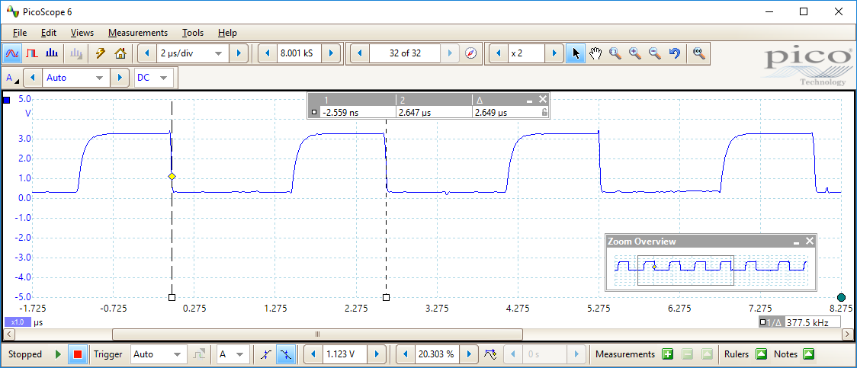

No 1.5k, with glitch (353.6 kHz)

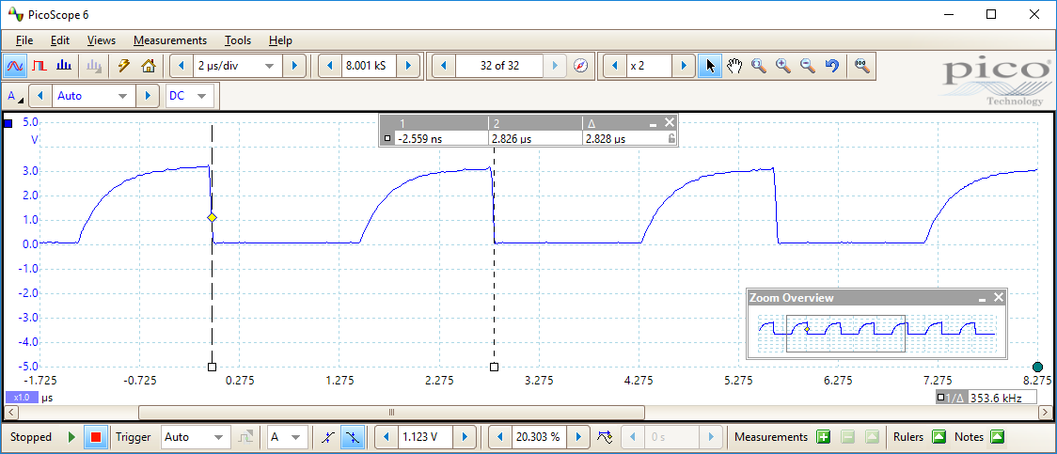

1.5k, 8mA, remove glitch (384.3 kHz)

